CSI College of Engineering, Ketti is proud of the achievements made by our respected Chairman and Bishop in recent years. In the year 2020, he was presented with ***“Lifetime Achievement Award”*** conferred by Srimathi Innocent Divya, IAS then District Collector of the Nilgiris, on 25th of January 2020. This award was given by the **Society for Aerospace and Mechanical Professionals (SAMP)** in recognition of the recipient’s outstanding contributions to the field of Education.

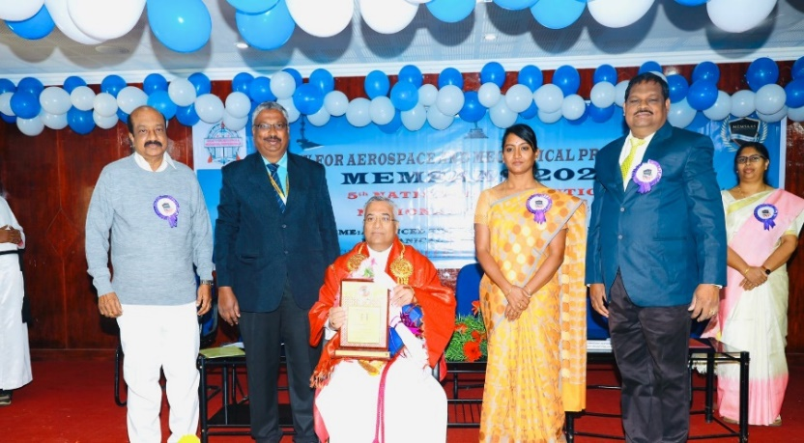

In the year 2024, he was presented with “***Trendsetters 2024 Award*”** conferredby by Thiru. Ma. Subramanian, Honourable Minister for Health and Family Welfare Government of Tamil Nadu on 30th of June 2024. This award is given by **Times of India, Chennai** for his dedicated contributions in developing well rounded students and nurturing future leaders from underprivileged communities in society through academics.

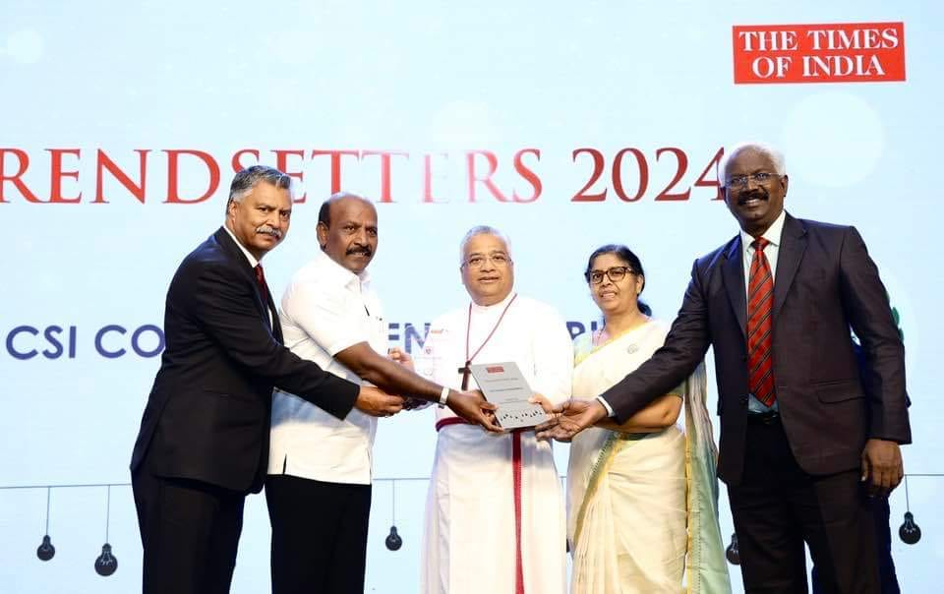

We wish and pray that the services of our Chairman should continue for the years to come so that this Educational Institution can grow an extra mile in serving the student community.